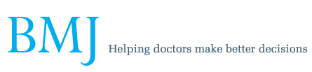

Letter

Readmission rates
Anthony Cohn, paediatrician
West Hertfordshire Hospitals NHS Trust, Watford General Hospital, Watford WD18 0HB, UK

Readmission rates are a poor marker of quality
BMJ 2014; 348 doi: http://dx.doi.org/10.1136/bmj.g1148 (Published 29 January 2014)
Cite this as: BMJ 2014;348:g1148
Using readmission as a marker of discharge failure shows unidimensional thought typical of many “measurements” of quality.1
Discharge from hospital should occur when the risks of being in the community (usually exaggerated) are less than those of remaining in hospital (usually ignored) or the benefits of discharge (often ignored) are greater than the benefits of remaining in hospital (usually over-rated). As with all judgments, there will be some error.
If readmission becomes yet another stick to beat the medical profession with, and every readmission is considered a failure, then doctors will “play safe” and increase the length of stay. The hospital induced morbidity and negative effects on patients and families of this change would remain unmeasured.
A hospital with no readmissions is probably needlessly delaying discharge of a large number of patients. It would be sensible to ascertain what figure reflects a suitable balance between these conflicting requirements—most likely a few per cent of all admissions. Having readmission rates above—or equally importantly below—the expected level should prompt a review of practice.
Cite this as: BMJ 2014;348:g1148

